|  |  |
| --- | --- |
|  | **MINISTRY OF EDUCATION AND TRAINING** |

**FPT UNIVERSITY**

|  |  |
| --- | --- |
| Capstone Project Document | |
| **Face Detection For Delivery Payment** | |
| **Group 5 - IS** | |
| **Group members** | Nguyễn Văn Hiếu – SE61961 (Leader)  Đinh Phú Thắng – SE62528  Trần Trọng Nghĩa – SE62278  Nguyễn Hữu Lâm– SE61234 |
| **Supervisor** | Nguyễn Huy Hùng |
| **Ext. Supervisor** | N/A |
| **Project Code** | FDDP |

– **Ho Chi Minh City, 20 January 2019** –

# Software Requirement Specification

1. **User Requirement Specification**
   1. **Guest Requirement**

Guest is a person who doesn’t have access to the system. Guest can use some functions in the system. To use all functions, guest must login. These are some functions guest can use:

* Register.
* Login.
  1. **Customer Requirement**
* View stores list.
* View products of stores.
* Add to cart.
* Make a payment for orders.
* Feedback.
* Cancel orders.
* View history orders.
* Edit profile.
* Add Customer receiver.
* Log out.
  1. **Admin Requirement**
* Manage users
  + - * + Search Users.
        + View detail of users.
        + Send email to users.
* Manage orders
  + - * + Search Orders.
        + View detail of orders.
        + Approve payment for orders.
        + Edit orders.
* Manage shipper
  + - * + Search shipper.
        + View detail of user.
        + Edit-Update detail of user.
* Manage stores
  + - * + Search stores.
        + View detail of stores.
        + Add new stores.
        + Edit stores.
* Manage products
  + - * + Search products.
        + View detail of products.
        + Add new products.
        + Edit products.
* Log out
  1. **Shipper Requirement**
* Receive orders.
* View detail of orders.
* View Shipper profile.
* Edit profile.
* View profit.
* View orders history.
* View routing for shipper.
* Verify Customer face for payment.

1. **System Requirement Specification**

## **2.1 External Interface Requirement**

### **2.1.1 User Interface**

* + - GUI should be simple, clear, intuitive, and reminiscent.
    - The interface design is an iterate process includes: design, sketching, prototyping, user assessment.
    - The User Interface uses language is English.

### **2.1.2 Hardware Interface**

* Desktop PC.
* Mobile Device.

### **2.1.3 Software Interface**

* At least android 6.0 or IOS 10 device.
* Web application: work with browsers Firefox (v52 or higher), Chromes (v28 or higher), Internet Explorer (v10 or above) or with any web browser that supports HTML5 & CSS3.

### **2.1.4 Communication Protocol**

* Use HTTP protocol 1.1 for communication between:

Web application and web server.

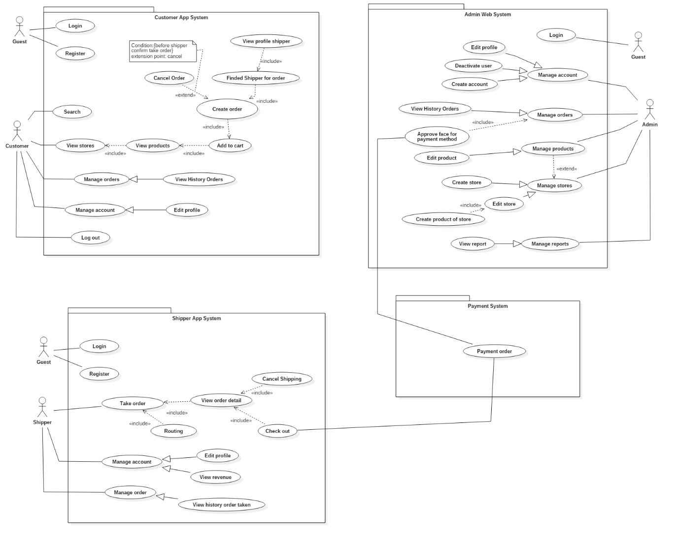

## **2.2 System Overview Use Case**

### Figure 2: System Overview Use Case

## **2.3 List of Use Case**

### **2.3.1 <Guest> Overview Use Case**

Figure 3: <Guest> Registration Use Case

### **2.3.1.1 <Guest> Register Account**

### Figure 4: <Guest> Registration Use Case

|  |  |  |  |  |  |  |
| --- | --- | --- | --- | --- | --- | --- |
| **USE CASE – UC_G.01** | | | | | | |
| **Use Case No.** | | UC_G.01 | | **Use Case Version** | | 1.0 |
| **Use Case Name** | | Register account | | | | |
| **Author** | | ThangDP | | | | |
| **Date** | | 18/1/2019 | | **Priority** | High | |
| **Actor:**   * Guest   **Summary:**   * This use case allows guest to register new account for using system.   **Goal:**   * Guest have new account to use system.   **Triggers:**   * Guest send register command on mobile application.   **Preconditions:**   * N/A   **Post Conditions:**   * Success: navigator to login screens for login * Fail: show error message   **Main Success Scenario:** | | | | | | |
| **Step** | **Actor Action** | | **System Response** | | | |
| 1 | Guest press “Sign Up” link | | System requires identity information from Guest:   * Mobile phone: (+84) number text input, required, length 10-11. * Password: free text input, required, length 8-20. * Email: free text input, required, length 3-250. * Birthdate: date time input, required. * Paypal username: free text input, required, length 3-250. * Paypal password: free text input, required, length 8-20. * Sign Up: button, required. * Take Picture: button, required. | | | |
| 2 | Guest inputs information | |  | | | |
| 3 | Guest press “Sign Up” button. | | System show message  “Notification.  We want to add your face for payment. Do you want to continue sign up?” | | | |
| 4 | Guest press “Add” button. | | System change to camera screen to shot face of customer. | | | |
| 5 | Take Photos | |  | | | |
| 6 | Guest send command to register account for system. | | System validate information, display contract details and requires for confirmation.  [Exception 1] | | | |
| **Alternative Scenario**: N/A | | | | | | |
| **Exceptions**: | | | | | | |
| **Step** | **Actor Action** | | **System Response** | | | |
| 1 | Any field in form is null | | System return message “Form cannot null” | | | |
| **Relationships:** N/A  **Business Rules:**   * Password are encrypted before being sent to database. * If information is invalid, system sends message to inform user and allows user to edit input information * If all information is valid, system checks if phone number has already existed in system or not. * If phone number is duplicated in the system, system sends message to inform user change phone number | | | | | | |

### Table : <Guest> Registration Use Case

**2.3.1.2 <Guest> Log in**

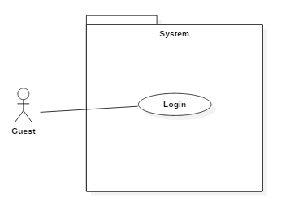

Figure 5: < Guest > Log in

|  |  |  |  |  |  |  |
| --- | --- | --- | --- | --- | --- | --- |
| **USE CASE – UC_G.02** | | | | | | |
| **Use Case No.** | | UC_G.02 | | **Use Case Version** | | 1.0 |
| **Use Case Name** | | Log in | | | | |
| **Author** | | ThangDP | | | | |
| **Date** | | 23/1/2019 | | **Priority** | High | |
| **Actor:**   * Guest   **Summary:**   * This use case allows guest to log in.   **Goal:**   * Guest log in.   **Triggers:**   * Guest send log in command on mobile application (Customer, Shipper) or web application (Admin).   **Preconditions:**   * N/A   **Post Conditions:**   * Success: Guest log in to system. * Fail: Show error message.   **Main Success Scenario:** | | | | | | |
| **Step** | **Actor Action** | | **System Response** | | | |
| 1 | Guest goes to login view. | | System requires identity information from Guest:   * Mobile Phone: number text input, required, length 10-11. * Password: free text input, required, length 8-20. * Login: button, required.   Sign Up: link to register page, required. | | | |
| **Alternative Scenario**: N/A | | | | | | |
| **Exceptions**: | | | | | | |
| **Step** | **Actor Action** | | **System Response** | | | |
| 1 | Username and password are not matching or cannot found in system | | System returns message ‘Wrong username or password’ | | | |
| **Relationships:** N/A  **Business Rules:**   * Authorized user inputs login information:   + Phone number: number  + Password: text input   * Then send login command * System will authenticate, let user login to system and authorize to redirect according to their specific role | | | | | | |

### Table : <Guest > Log in

### **2.3.2 <Customer> Overview Use Case**

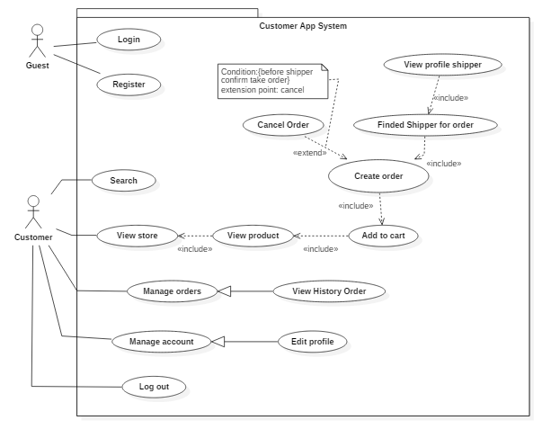

### Figure 6: < Customer > Over view use case

### **2.3.2.1 < Customer > Search store**

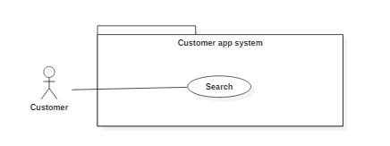

### Figure 9: < Customer > Search store

|  |  |  |  |  |  |  |
| --- | --- | --- | --- | --- | --- | --- |
| **USE CASE – UC_C.01** | | | | | | |
| **Use Case No.** | | UC_C.01 | | **Use Case Version** | | 1.0 |
| **Use Case Name** | | Search store | | | | |
| **Author** | | ThangDP | | | | |
| **Date** | | 23/1/2019 | | **Priority** | Normal | |
| **Actor:**   * Customer   **Summary:**   * This use case allows customers search store   **Goal:**   * Show the store which customers search   **Triggers:**   * Customer send search command   **Preconditions:**   * Account have role “member”   **Post Conditions:**   * Success: Show store on screen * Fail: Send message not found   **Main Success Scenario:** | | | | | | |
| **Step** | **Actor Action** | | **System Response** | | | |
| 1 | Customer go to “Home” page. | | Display on screen:   * Search: search area, required. * Product Suggest: * Store Name + Store Address: text area, required. * Product’s product: image, required. * Price: double, required. * Store suggest: * Store Name + Store Address: text area, required. | | | |
| 2 | Customers send search command | | System search store which customer send.  [Alternative 1] | | | |
| **Alternative Scenario:** | | | | | | |
| **Step** | **Actor Action** | | **System Response** | | | |
| 1 | Store not found | | Show message not found for customer | | | |
| **Exceptions**: N/A | | | | | | |
| **Relationships:** N/A  **Business Rules:** Customer search for store they need, If don’t have any store like they search, System will return no result and client will so message “not found store” for customer. | | | | | | |

### Table: <Customer> Search store

### **2.3.2.2 < Customer >Order (C02)**

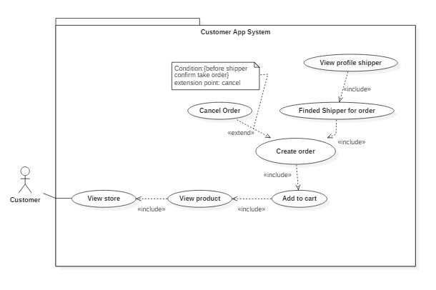

### Figure 10: < Customer > Order

### **2.3.2.2.1 < Customer >View store detail**

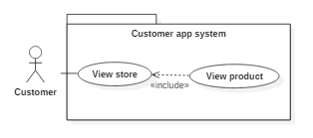

### Figure 11: < Customer > View store detail

|  |  |  |  |  |  |  |
| --- | --- | --- | --- | --- | --- | --- |
| **USE CASE – UC_C.02A** | | | | | | |
| **Use Case No.** | | UC_C.02A | | **Use Case Version** | | 1.0 |
| **Use Case Name** | | View store detail | | | | |
| **Author** | | ThangDP | | | | |
| **Date** | | 23/1/2019 | | **Priority** | High | |
| **Actor:**   * Customer   **Summary:**   * Customer send command to view store   **Goal:**   * Show detail store for customer   **Triggers:**   * Customer send store id command   **Preconditions:**   * Account have role “member”   **Post Conditions:**   * Success: Show store detail on screen. * Fail: Show loading screen and log exception on command line.   **Main Success Scenario:** | | | | | | |
| **Step** | **Actor Action** | | **System Response** | | | |
| 1 | Customers send view store detail command | | System show store follow store id for customer  System show on screen:   * Store’s Images: images, required. * Store Name – Store Address: text, required. * Open time: text, required. * Product List: * Product’s Name: text, required. * Product’s Price: text, required. * ‘_’: minus button, required. * ‘+’: plus button, required. * “Order Cart-Total Price”: button, required. | | | |
| **Alternative Scenario:** N/A | | | | | | |
| **Exceptions**: N/A | | | | | | |
| **Relationships:** N/A  **Business Rules:** N/A | | | | | | |

### Table : <Customer> View store

### **2.3.2.2.2 < Customer >Add to cart**

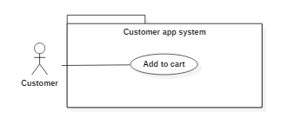

### Figure 12: < Customer > Add to cart

|  |  |  |  |  |  |  |
| --- | --- | --- | --- | --- | --- | --- |
| **USE CASE – UC_C.02B** | | | | | | |
| **Use Case No.** | | UC_C.02B | | **Use Case Version** | | 1.0 |
| **Use Case Name** | | Add to cart | | | | |
| **Author** | | ThangDP | | | | |
| **Date** | | 25/1/2019 | | **Priority** | Normal | |
| **Actor:**   * Customer   **Summary:**   * Customer send command add product to cart   **Goal:**   * Add product to cart * Show cart for customer   **Triggers:**   * Customer send product id command for add to cart   **Preconditions:**   * Account have role “member”   **Post Conditions:**   * Success: Show cart on screen * Fail:   **Main Success Scenario:** | | | | | | |
| **Step** | **Actor Action** | | **System Response** | | | |
| 1 | Customers send product id for adding to cart | | System add product to cart follow product id for customer.  System will show on screen:   * Customer Address: text, required. * Store Address: text, required. * Product’s Photo: image, required. * Product’s Quantity: int, required. * Product’s Price: double, required. * Subtotal: double, required. * Delivery Fee: double, required. * Total: double, required. * Shipper Earn: double, required. * Custome Information area: * Full Name: text, required. | | | |
| **Alternative Scenario:** N/A | | | | | | |
| **Exceptions**: N/A | | | | | | |
| **Relationships:** N/A  **Business Rules:** N/A | | | | | | |

### Table : <Customer> Add to cart

### **2.3.2.2.3 < Customer >Create order**

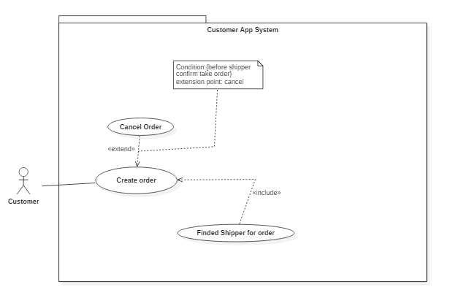

### Figure 13: < Customer > Create order

|  |  |  |  |  |  |  |
| --- | --- | --- | --- | --- | --- | --- |
| **USE CASE – UC_C.02C** | | | | | | |
| **Use Case No.** | | UC_C.02C | | **Use Case Version** | | 1.0 |
| **Use Case Name** | | Create Order | | | | |
| **Author** | | ThangDP | | | | |
| **Date** | | 25/1/2019 | | **Priority** | High | |
| **Actor:**   * Customer   **Summary:**   * This use case is escribes how to create order, cancel it or view shipper info when taken by shipper   **Goal:**   * Create order   **Triggers:**   * Customer send create order command   **Preconditions:**   * Account have role “member”   **Post Conditions:**   * Success: Show popup loading for finding shipper * Fail:   **Main Success Scenario:** | | | | | | |
| **Step** | **Actor Action** | | **System Response** | | | |
| 1 | Customers send product id for adding to cart | | System add product to cart follow product id for customer  [Alternative 1] | | | |
|  |  | |  | | | |
| **Alternative Scenario:** | | | | | | |
| **Step** | **Actor Action** | | **System Response** | | | |
| 1 | Customer cancel order | | System will cancel order and return to cart for customer | | | |
| **Exceptions**: | | | | | | |
| **Step** | **Actor Action** | | **System Response** | | | |
|  |  | |  | | | |
| **Relationships:** N/A  **Business Rules:** - Customer only can cancel order before shipper confirm take order from store | | | | | | |

### Table : <Customer> Create order

### **2.3.2.2.4 < Customer >View list order**

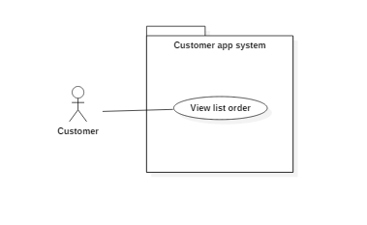

### Figure 14: < Customer > View list order

|  |  |  |  |  |  |  |
| --- | --- | --- | --- | --- | --- | --- |
| **USE CASE – UC_C.02D** | | | | | | |
| **Use Case No.** | | UC_C.02D | | **Use Case Version** | | 1.0 |
| **Use Case Name** | | View list order | | | | |
| **Author** | | ThangDP | | | | |
| **Date** | | 25/1/2019 | | **Priority** | Normal | |
| **Actor:**   * Customer   **Summary:**   * Customer send view list order command   **Goal:**   * Show list of order by customer   **Triggers:**   * Customer send view list order command   **Preconditions:**   * Account have role “member”   **Post Conditions:**   * Success: Show list order of customer * Fail:   **Main Success Scenario:** | | | | | | |
| **Step** | **Actor Action** | | **System Response** | | | |
| 1 | Customer send view list order command | | System show list order on screen:  [Alternative 1]   * Order Code: text, required. * Date Booked: date, required. * Total: double, required. | | | |
| 2 | Customer click link of order list. | | System will show on screen:   * Customer Address: text, required. * Store Address: text, required. * Product’s Photo: image, required. * Product’s Quantity: int, required. * Product’s Price: double, required. * Subtotal: double, required. * Delivery Fee: double, required. * Total: double, required. * Shipper Earn: double, required. * Custome Information area:   Full Name: text, required. | | | |
| **Alternative Scenario:** | | | | | | |
| **Step** | **Actor Action** | | **System Response** | | | |
| 1 | No order in list | | System show “No order is created yet” | | | |
| **Exceptions**: | | | | | | |
| **Step** | **Actor Action** | | **System Response** | | | |
|  |  | |  | | | |
| **Relationships:** N/A  **Business Rules:** N/A | | | | | | |

Table : <Customer> View list order

### **2.3.3 <Shipper> Overview Use Case**

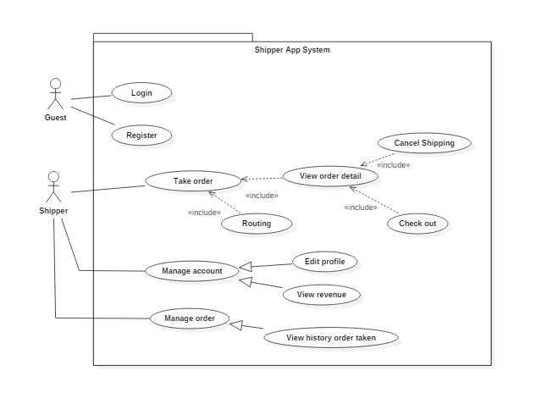

### Figure 15: < Shipper > Over view use case

### **2.3.3.1 <Shipper> Take order**

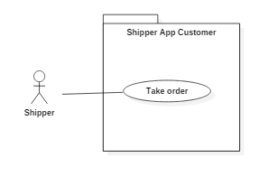

### Figure 16: < Shipper > Take order

|  |  |  |  |  |  |  |
| --- | --- | --- | --- | --- | --- | --- |
| **USE CASE – UC_S.01A** | | | | | | |
| **Use Case No.** | | UC_S.01A | | **Use Case Version** | | 1.0 |
| **Use Case Name** | | Take order | | | | |
| **Author** | |  | | | | |
| **Date** | | 25/1/2019 | | **Priority** | High | |
| **Actor:**   * Shipper   **Summary:**   * Shipper turn on shipper mode   **Goal:**   * Assign order nearest shipper’s location   **Triggers:**   * Shipper send ready ship command   **Preconditions:**   * Account have role “shipper”   **Post Conditions:**   * Success: Assign order for customer * Fail:   **Main Success Scenario:** | | | | | | |
| **Step** | **Actor Action** | | **System Response** | | | |
| 1 | Shipper turn on mode shipper | | System will auto assign order nearest shipper’s loaction (10km radius)  [Alternative 1] | | | |
| **Alternative Scenario:** | | | | | | |
| **Step** | **Actor Action** | | **System Response** | | | |
| 1 | Can not find order | | System show “No order is created yet” | | | |
| **Exceptions**: | | | | | | |
| **Step** | **Actor Action** | | **System Response** | | | |
|  |  | |  | | | |
| **Relationships:** N/A  **Business Rules:** N/A | | | | | | |

Table : <Shipper> Take order

### **2.3.3.2 <Shipper> View profile**

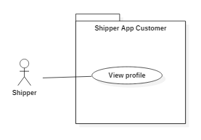

### Figure 17: < Shipper > View profile

|  |  |  |  |  |  |  |
| --- | --- | --- | --- | --- | --- | --- |
| **USE CASE – UC_S.01B** | | | | | | |
| **Use Case No.** | | UC_S.01B | | **Use Case Version** | | 1.0 |
| **Use Case Name** | | View profile | | | | |
| **Author** | |  | | | | |
| **Date** | | 26/1/2019 | | **Priority** | Normal | |
| **Actor:**   * Shipper   **Summary:**   * Shipper view profile   **Goal:**   * View profile for shipper   **Triggers:**   * Shipper send view profile command   **Preconditions:**   * Account have role “shipper”   **Post Conditions:**   * Success: Show profile for shipper * Fail:   **Main Success Scenario:** | | | | | | |
| **Step** | **Actor Action** | | **System Response** | | | |
| 1 | Shipper send view profile command | | System show profile shipper | | | |
| **Alternative Scenario:** N/A | | | | | | |
| **Exceptions**: N/A | | | | | | |
| **Relationships:** N/A  **Business Rules:** N/A | | | | | | |

Table : <Shipper> Take order

### **2.3.3.3 <Shipper> View profile**



### Figure 18: < Shipper > View profile

|  |  |  |  |  |  |  |
| --- | --- | --- | --- | --- | --- | --- |
| **USE CASE – UC_S.01B** | | | | | | |
| **Use Case No.** | | UC_S.01B | | **Use Case Version** | | 1.0 |
| **Use Case Name** | | View profile | | | | |
| **Author** | |  | | | | |
| **Date** | | 26/1/2019 | | **Priority** | Normal | |
| **Actor:**   * Shipper   **Summary:**   * Shipper view profile   **Goal:**   * View profile for shipper   **Triggers:**   * Shipper send view profile command   **Preconditions:**   * Account have role “shipper”   **Post Conditions:**   * Success: Show profile for shipper * Fail:   **Main Success Scenario:** | | | | | | |
| **Step** | **Actor Action** | | **System Response** | | | |
| 1 | Shipper send view profile command | | System show profile shipper | | | |
| **Alternative Scenario:** N/A | | | | | | |
| **Exceptions**: N/A | | | | | | |
| **Relationships:** N/A  **Business Rules:** N/A | | | | | | |

Table : <Shipper> Take order

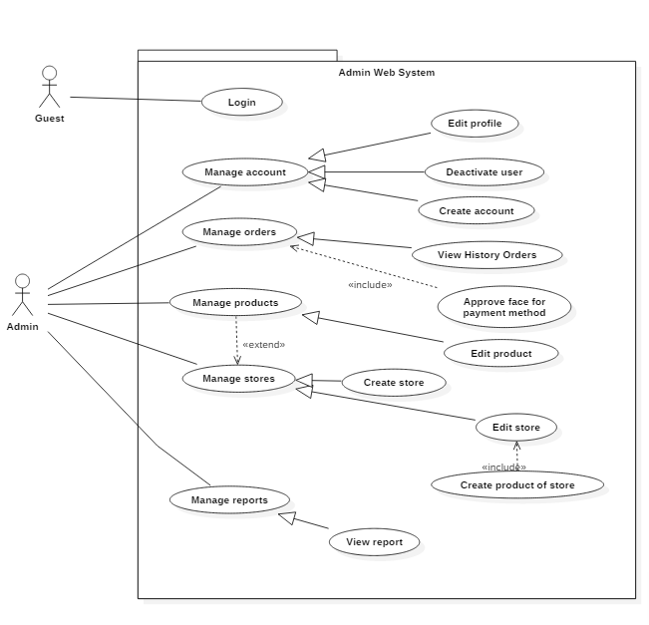**2.3.4 <Admin> Overview Use Case**

### Figure 19: < Admin > Over view use case

### **2.3.4.1 <Admin> Manage order**

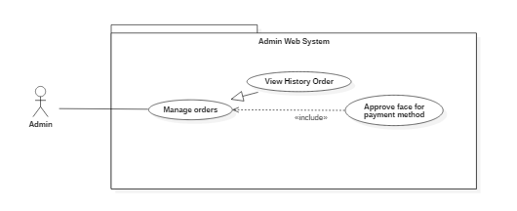Figure 20 : < Admin> Manage Order Overview

### **2.3.4.1.1 <Admin> View history order**

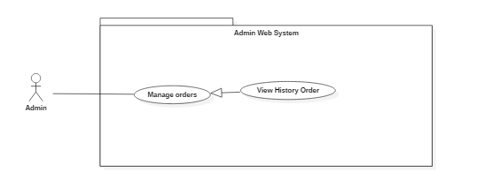

Figure 21 : < Admin> View history Order

|  |  |  |  |  |  |  |
| --- | --- | --- | --- | --- | --- | --- |
| **USE CASE – UC_A.01A** | | | | | | |
| **Use Case No.** | | UC_A.01A | | **Use Case Version** | | 1.0 |
| **Use Case Name** | | View history order | | | | |
| **Author** | | ThangDP | | | | |
| **Date** | | 28/1/2019 | | **Priority** | Normal | |
| **Actor:**   * Admin   **Summary:**   * Admin view history order.   **Goal:**   * Admin sees list history order.   **Triggers:**   * Admin send view order command.   **Preconditions:**   * User role is “admin”.   **Post Conditions:**   * Success: Show list history order. * Fail:   **Main Success Scenario:** | | | | | | |
| **Step** | **Actor Action** | | **System Response** | | | |
| 1 | Admin send view order command | | System show list history order   * “Search”: text area, required.   Data Table which contains:   * + “Code”: Code of order, text, required.   + “Buyer Phone”: text area, required.   + “Buyer Name”: text, required.   + “Total Price”: integer, required.   + “Status”: text area, required.   The value of status:   1. New: Order is new 2. Assigned: Order is assigned. 3. Bought: Order is bought. 4. Done: Order is done. 5. Cancel: Order is cancelled. | | | |
| 2 | Admin click row of order list to view detail of order. | | Display the view order detail modal on screen:   * “Customer Face”: image area, required. * “Bill”: image area, required. * “Order Code”: text area, required. * “Customer Phone”: text area, required. * “Customer Name”: text area, required. * “Shipper Phone”: text area, required. * “Shipper Name”: text area, required. * “Status”: text area, required. * “Customer Longitude”: text area, required. * “Customer Latitude”: text area, required. * “Store Longitude”: text area, required. * “Store Latitude”: text area, required. * “Store Name”: text area, required. * “Store Address”: text area, required. * “Customer Description”: text area, required. * “Customer Address”: text area, required. * “Receive Time”: text area, required. * “Note”: text area, required.   Data Table:   * + “#”: Code of product, text, required.   + “Product”: text, required.   + “Price”: text, required.   + “Unit”: integer, required.   + “Cost”: double, required.   + “Sub Total”: double, required.   + “Shipping Fee”: double, required.   + “Total”: double, required.   + “Save”: button, required.   + “Close”: button, required. | | | |
| 3 | Admin add photo provide by customer to verify his(her) order | | System will compare with the photo in customer account to verify  [Exception 1] | | | |
| **Alternative Scenario: N/A** | | | | | | |
| **Exceptions**: | | | | | | |
| **Step** | **Actor Action** | | **System Response** | | | |
| 1 | Can not verify customer face | | Show message “Wrong user’s face or try again.” | | | |
| **Relationships:** N/A  **Business Rules:** N/A | | | | | | |

### Table : <Admin> View order

### **2.3.4.1.2 <Admin> Approve face for payment**

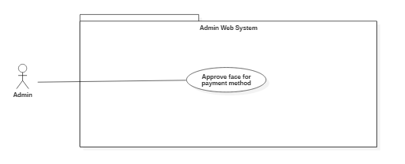

Figure 21 : < Admin> Approve face for payment

|  |  |  |  |  |  |  |
| --- | --- | --- | --- | --- | --- | --- |
| **USE CASE – UC_A.01B** | | | | | | |
| **Use Case No.** | | UC_A.01B | | **Use Case Version** | | 1.0 |
| **Use Case Name** | | Approve face for payment | | | | |
| **Author** | | ThangDP | | | | |
| **Date** | | 28/1/2019 | | **Priority** | Normal | |
| **Actor:**   * Admin   **Summary:**   * Admin approve customer’s face for payment.   **Goal:**   * Customer’s face is approved.   **Triggers:**   * Admin send approve command.   **Preconditions:**   * User role is “admin”.   **Post Conditions:**   * Success: Show payment success. * Fail:   **Main Success Scenario:** | | | | | | |
| **Step** | **Actor Action** | | **System Response** | | | |
| 1 | Admin add photo provide by customer to verify his(her) order | | System load into screen. | | | |
| 2 | Admin click “Save” button. | | System will compare with the photo in customer account to verify  [Exception 1] | | | |
| **Alternative Scenario: N/A** | | | | | | |
| **Exceptions**: | | | | | | |
| **Step** | **Actor Action** | | **System Response** | | | |
| 1 | Can not verify customer face | | Show message “Wrong user’s face or try again.” | | | |
| **Relationships:** N/A  **Business Rules:** N/A | | | | | | |

Table : <Admin> Approve face for payment

### **2.3.4.2 <Admin> Manage account(A02)**

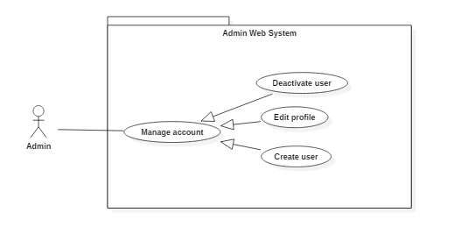

### Figure 22 : < Admin> Manage account

### **2.3.4.2.1 <Admin> Deactive user**

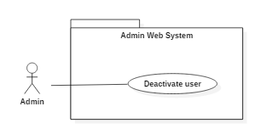

### Figure 23 : < Admin> Deactive user

|  |  |  |  |  |  |  |
| --- | --- | --- | --- | --- | --- | --- |
| **USE CASE – UC_A.02A** | | | | | | |
| **Use Case No.** | | UC_A.02A | | **Use Case Version** | | 1.0 |
| **Use Case Name** | | Deactive user | | | | |
| **Author** | | ThangDP | | | | |
| **Date** | | 30/1/2019 | | **Priority** | Normal | |
| **Actor:**   * Admin   **Summary:**   * Deactive account user   **Goal:**   * Account user is deactived   **Triggers:**   * Admin send deactive account command   **Preconditions:**   * User role is “admin”.   **Post Conditions:**   * Success: Account is deactived * Fail:   **Main Success Scenario:** | | | | | | |
| **Step** | **Actor Action** | | **System Response** | | | |
| 1 | * Admin lick row on list of User. | | * System will show modal: * “Phone”: phone number, text, length 10-11, required. * “Full name”: text area, required. * “Date of Birth”: date time, required. * “Email”: text area, required. * “Status”: select, required. * “Sub”: select, required. * “Note”: text area, required. * “Cancel”: button, required. * “Save”: button, required. | | | |
| 2 | * Admin change Status to “Banned” and click “Save”. | | * System deactive account which specify. | | | |
| **Alternative Scenario:** N/A | | | | | | |
| **Exceptions**: N/A | | | | | | |
| **Relationships:** N/A  **Business Rules:** N/A | | | | | | |

### Table : <Admin> Deactive user

### **2.3.4.2.2 <Admin> Edit profile**

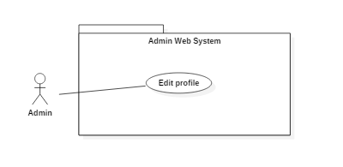

### Figure 24 : < Admin> Edit profile

|  |  |  |  |  |  |  |
| --- | --- | --- | --- | --- | --- | --- |
| **USE CASE – UC_A.02B** | | | | | | |
| **Use Case No.** | | UC_A.02B | | **Use Case Version** | | 1.0 |
| **Use Case Name** | | Edit profile | | | | |
| **Author** | | ThangDP | | | | |
| **Date** | | 30/1/2019 | | **Priority** | Normal | |
| **Actor:**   * Admin   **Summary:**   * Admin will edit profile account which is specified   **Goal:**   * Edit profile account   **Triggers:**   * Admin send request update profile account   **Preconditions:**   * User role is “admin”.   **Post Conditions:**   * Success: Account is updated * Fail:   **Main Success Scenario:** | | | | | | |
| **Step** | **Actor Action** | | **System Response** | | | |
| 1 | Admin lick row on list of Account. | | System will show modal:   * Customer account:   + Full name: string, required  + Email: string, null able  + Note: string, null able   * Shipper account:   + Phone number: number, required, 10-12 characters  + Date of birth: format mm/dd/yyy, required  + Email: format: [abc@gmail.com](mailto:abc@gmail.com), required  + Portrait: image of user account, required  + Nation ID number: number, required  + Issue date: format mm/dd/yyyy,, required  + Bike register ID number: number, required  + Issue date: format mm/dd/yyyy, required   * Admin account:   + Full name: string, required  + Date of birth: format mm/dd/yyyy, required  + Email: format [abc@gmail.com](mailto:abc@gmail.com), required  + Nation ID number: number, required   * + Date of issue: format mm/dd/yyyy, required | | | |
| 2 | Admin change data of customer and click “Save”. | | System will update information profile account  [Exception 1][Exception 2] | | | |
| **Alternative Scenario:** | | | | | | |
| **Step** | **Actor Action** | | **System Response** | | | |
|  |  | |  | | | |
| **Exceptions**: | | | | | | |
| **Step** | **Actor Action** | | **System Response** | | | |
| 1 | Null require field | | System show message “Field is required !” | | | |
| 2 | Not follow the format | | System show message “Field is not follow the format” | | | |
| **Relationships:** N/A  **Business Rules:** N/A | | | | | | |

### Table : <Admin> Edit profile

### **2.3.4.2.3 <Admin> Create user**

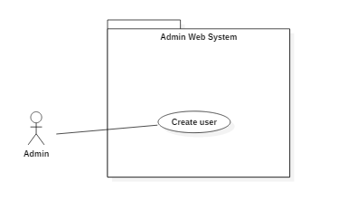

### Figure 25 : < Admin> Create user

|  |  |  |  |  |  |  |
| --- | --- | --- | --- | --- | --- | --- |
| **USE CASE – UC_A.02C** | | | | | | |
| **Use Case No.** | | UC_A.02C | | **Use Case Version** | | 1.0 |
| **Use Case Name** | | Create user | | | | |
| **Author** | | ThangDP | | | | |
| **Date** | | 30/1/2019 | | **Priority** | Normal | |
| **Actor:**   * Admin   **Summary:**   * Create new account   **Goal:**   * Create a new account   **Triggers:**   * Admin send create account command   **Preconditions:**   * User role is “admin”.   **Post Conditions:**   * Success: Account is created * Fail:   **Main Success Scenario:** | | | | | | |
| **Step** | **Actor Action** | | **System Response** | | | |
| 1 | Admin click “Add New” | | * Shipper account:   + Phone number: number, required, 10-12 characters  + Date of birth: format mm/dd/yyy, required  + Email: format: [abc@gmail.com](mailto:abc@gmail.com), required  + Portrait: image of user account, required  + Nation ID number: number, required  + Issue date: format mm/dd/yyyy,, required  + Bike register ID number: number, required  + Issue date: format mm/dd/yyyy, required   * Admin account:   + Full name: string, required  + Date of birth: format mm/dd/yyyy, required  + Email: format [abc@gmail.com](mailto:abc@gmail.com), required  + Nation ID number: number, required  + Date of issue: format mm/dd/yyyy, required | | | |
| 2 | Admin input data and click “Save”. | | System will create new account  [Exception 1] [Exception 2] | | | |
| **Alternative Scenario:** | | | | | | |
| **Step** | **Actor Action** | | **System Response** | | | |
|  |  | |  | | | |
| **Exceptions**: | | | | | | |
| **Step** | **Actor Action** | | **System Response** | | | |
| 1 | Null require field | | System show message “Field is required !” | | | |
| 2 | Not follow the format | | System show message “Field is not follow the format” | | | |
| **Relationships:** N/A  **Business Rules:** | | | | | | |

### Table : <Admin> Create user

### **2.3.4.3 <Admin> Manage store**

### Figure 26 : < Admin> Manage store overview

### **2.3.4.3.1 <Admin> Create store**

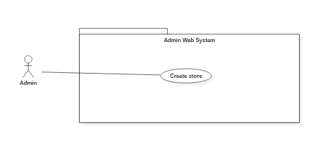

### Figure 27 : < Admin> Create store

|  |  |  |  |  |  |  |
| --- | --- | --- | --- | --- | --- | --- |
| **USE CASE – UC_A.03A** | | | | | | |
| **Use Case No.** | | UC_A.03A | | **Use Case Version** | | 1.0 |
| **Use Case Name** | | Create store | | | | |
| **Author** | | ThangDP | | | | |
| **Date** | | 30/1/2019 | | **Priority** | Normal | |
| **Actor:**   * Admin   **Summary:**   * Admin send create store command   **Goal:**   * Store is created   **Triggers:**   * Admin send create store command   **Preconditions:**   * User role is “admin”.   **Post Conditions:**   * Success: show store created * Fail:   **Main Success Scenario:** | | | | | | |
| **Step** | **Actor Action** | | **System Response** | | | |
| 1 | Admin goes to “Store” link. | | * Display the view on screen.   Store information:  + Name: String, required  + Phone number: number, required  + Address: String, required  + District: ComboBox, required  + City: ComboBox, required  + Longitude: number, required  + Latitude: number, required  + Image store: image, required  + Save: button, required  + Close: image, required | | | |
| 2 | Admin input new data and click “Save”. | | System show store created  [Exception 1] | | | |
| **Alternative Scenario:** | | | | | | |
| **Step** | **Actor Action** | | **System Response** | | | |
|  |  | |  | | | |
| **Exceptions**: | | | | | | |
| **Step** | **Actor Action** | | **System Response** | | | |
| 1 | Any field information is null | | System show message “field is not allow null” | | | |
| **Relationships:** N/A  **Business Rules:** N/A | | | | | | |

Table : <Admin> Create store

### **2.3.4.3.2 <Admin> Edit store**

### Figure 28 : < Admin> Edit store

|  |  |  |  |  |  |  |
| --- | --- | --- | --- | --- | --- | --- |
| **USE CASE – UC_A.03B** | | | | | | |
| **Use Case No.** | | UC_A.03B | | **Use Case Version** | | 1.0 |
| **Use Case Name** | | Edit store | | | | |
| **Author** | | ThangDP | | | | |
| **Date** | | 31/1/2019 | | **Priority** | Normal | |
| **Actor:**   * Admin   **Summary:**   * Admin send edit store command   **Goal:**   * Update informations’ store   **Triggers:**   * Admin send edit store command.   **Preconditions:**   * User role is “admin”.   **Post Conditions:**   * Success: Store Updated * Fail:   **Main Success Scenario:** | | | | | | |
| **Step** | **Actor Action** | | **System Response** | | | |
| 1 | Admin goes to “Store” link. | | * Display the view on screen.   Store information:  + Name: String, required  + Phone number: number, required  + Address: String, required  + District: ComboBox, required  + City: ComboBox, required  + Longitude: number, required  + Latitude: number, required  + Image store: image, required  + Save: button, required  + Close: image, required | | | |
| 2 | Admin edit data and click “Save” | | System update informations’ store  [Exception 1] | | | |
| **Alternative Scenario:** | | | | | | |
| **Step** | **Actor Action** | | **System Response** | | | |
|  |  | |  | | | |
| **Exceptions**: | | | | | | |
| **Step** | **Actor Action** | | **System Response** | | | |
| 1 | Null or not follow the format | | System show message “Field is not allow null” or  “Field is not correct format” | | | |
| **Relationships:** N/A  **Business Rules:** N/A | | | | | | |

Table : <Admin> Edit store

### **2.3.4.4 <Admin> Manage product**

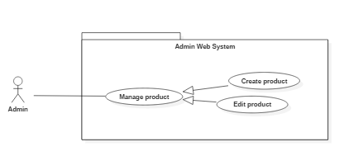

### Figure 26 : < Admin> Manage product overview

### **2.3.4.4.1 <Admin> Create product**

### Figure 27 : < Admin> Create product

|  |  |  |  |  |  |  |
| --- | --- | --- | --- | --- | --- | --- |
| **USE CASE – UC_A.04A** | | | | | | |
| **Use Case No.** | | UC_A.04A | | **Use Case Version** | | 1.0 |
| **Use Case Name** | | Create product | | | | |
| **Author** | | ThangDP | | | | |
| **Date** | | 30/1/2019 | | **Priority** | Normal | |
| **Actor:**   * Admin   **Summary:**   * Admin send create product command   **Goal:**   * Product is created   **Triggers:**   * Admin send create product command   **Preconditions:**   * User role is “admin”.   **Post Conditions:**   * Success: show product created * Fail:   **Main Success Scenario:** | | | | | | |
| **Step** | **Actor Action** | | **System Response** | | | |
| 1 | * Admin click on row of data table of detail store modal (store need to add new product). | | * System will change view of managing product (with id of store)   Data table:   * “Add new”: button, required. * “Search” text area, required. * “Delete” button, required.   On row of data table   * “Name”: text area, required. * “Price”: text area, required. * “Description”: text area, required. * “Note”: text area, required. * “Status”: text area, required. * “Delete” button group, required. | | | |
| 2 | Admin press “Add new” button. | | * System will modal of add new product: * “Name”: text area, required. * “Name of store”: text area, required. * “Price”: text area, required. * “Description”: text area, required. * “Note”: text area, required. * “Images”: image, required. * “Status”: text area, required. * “Cancel”: button, required. * “Save”: button, required. | | | |
| 3 | Admin input data and click “Save”. | | System show store product  [Exception 1] | | | |
| **Alternative Scenario:** | | | | | | |
| **Step** | **Actor Action** | | **System Response** | | | |
|  |  | |  | | | |
| **Exceptions**: | | | | | | |
| **Step** | **Actor Action** | | **System Response** | | | |
| 1 | Any field information is null | | System show message “field is not allow null” | | | |
| **Relationships:**   * View list of stores. * Search stores. * View detail of stores.   **Business Rules:** N/A | | | | | | |

Table : <Admin> Create product

### **2.3.4.4.2 <Admin> Edit product**

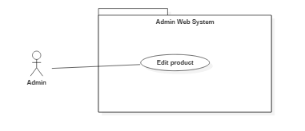

### Figure 28 : < Admin> Edit product

|  |  |  |  |  |  |  |
| --- | --- | --- | --- | --- | --- | --- |
| **USE CASE – UC_A.04B** | | | | | | |
| **Use Case No.** | | UC_A.04B | | **Use Case Version** | | 1.0 |
| **Use Case Name** | | Edit product | | | | |
| **Author** | | ThangDP | | | | |
| **Date** | | 31/1/2019 | | **Priority** | Normal | |
| **Actor:**   * Admin   **Summary:**   * Admin send edit product command   **Goal:**   * Update informations’ product   **Triggers:**   * Admin send edit product command.   **Preconditions:**   * User role is “admin”.   **Post Conditions:**   * Success: Product updated * Fail:   **Main Success Scenario:** | | | | | | |
| **Step** | **Actor Action** | | **System Response** | | | |
| 1 | * Admin click on row of data table of detail store modal (store need to add new product). | | * System will change view of managing product (with id of store)   Data table:   * “Add new”: button, required. * “Search” text area, required. * “Delete” button, required.   On row of data table   * “Name”: text area, required. * “Price”: text area, required. * “Description”: text area, required. * “Note”: text area, required. * “Status”: text area, required. * “Delete” button group, required. | | | |
| 2 | Admin press “Add new” button. | | * System will modal of add new product: * “Name”: text area, required. * “Name of store”: text area, required. * “Price”: text area, required. * “Description”: text area, required. * “Note”: text area, required. * “Images”: image, required. * “Status”: text area, required. * “Cancel”: button, required.   “Save”: button, required. | | | |
| 3 | Admin edit data and click “Save”. | | System update informations’ product  [Exception 1] | | | |
| **Alternative Scenario:** | | | | | | |
| **Step** | **Actor Action** | | **System Response** | | | |
|  |  | |  | | | |
| **Exceptions**: | | | | | | |
| **Step** | **Actor Action** | | **System Response** | | | |
| 1 | Null or not follow the format | | System show message “Field is not allow null” or  “Field is not correct format” | | | |
| **Relationships:**   * View list of stores. * Search stores. * View detail of stores.   **Business Rules:** N/A | | | | | | |

Table : <Admin> Edit product

### **2.3.4.5 <Admin> Manage report**

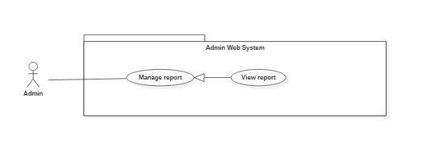

### Figure 26 : < Admin> Manage report overview

### **2.3.4.5.1 <Admin> View repor**

### Figure 27 : < Admin> View report

|  |  |  |  |  |  |  |
| --- | --- | --- | --- | --- | --- | --- |
| **USE CASE – UC_A.** | | | | | | |
| **Use Case No.** | | UC_A. | | **Use Case Version** | | 1.0 |
| **Use Case Name** | | View Report | | | | |
| **Author** | | LamNH | | | | |
| **Date** | | 5/3/2019 | | **Priority** | Normal | |
| **Actor:**   * Admin   **Summary:**   * This use case allows admin to view report and statistics of system.   **Goal:**   * Admin view report of order, customer, shipper, amount.   **Triggers:**   * Admin send log in command on web application (Admin). * System show web’s screen with admin role. * Admin press “Home” link.   **Preconditions:**   * User must be “admin”.   **Post Conditions:**   * Success: Show list of order on screen. * Fail: If list is null, show table with null data on screen.   **Main Success Scenario:** | | | | | | |
| **Step** | **Actor Action** | | **System Response** | | | |
| 1 | Admin goes to admin screen view. | | * Display the view on screen.   + “Home” link.   + “Account” link.   + “Order” link.   + “Product” link.   + “Store” link. | | | |
| 2 | Admin goes to “Home” link. | | * Display the view on screen. * “Actived Shipper”: item, required. * All: number. * Today: number. * This Week: number. * This Month: number. * “Customer Registration”: item, required. * All: number. * Today: number. * This Week: number. * This Month: number. * “Stores Partners”: item, required. * All: number. * Today: number. * This Week: number. * This Month: number. * “Orders Created”: item, required. * All: number. * Today: number. * This Week: number. * This Month: number. * “Ratio (Success)”: item, required. * All: number. * Today: number. * This Week: number. * This Month: number. * “Sold Products”: item, required. * All: number. * Today: number. * This Week: number. * This Month: number. * “Revenue Amount”: item, required. * All: number. * Today: number. * This Week: number. * This Month: number. * “Paid Shipper Amount”: item, required. * All: number. * Today: number. * This Week: number. * This Month: number.   Data Chart which contains:   * + “Type”: Type Report selects, required.   + “Date”: Time Report selects, required.   + “From”: date picker, required.   + “To”: date picker, required.   + “X”: label with date time, required.   + “Y”: label with number of reports, required.   The value of type “Order”:   1. New: Order is new 2. Assigned: Order is assigned. 3. Bought: Order is bought. 4. Received: Order is done. 5. Canceled: Order is cancelled.   The value of type “Product Sold”:   1. Sold Products: Product is sold.   The value of type “Rate Successful”:   1. Success rate: Ratio of success order. 2. Canceled rate: Ratio of canceled order.   The value of type “Total Amount”:   1. Total Amount: Revenue amount. 2. Paid Shipper Amount: Amount paid for shipper.   The value of Date “Day”: dd/mm/yyyy.  The value of Date “Week”: dd/mm/yyyy.  The value of Date “Month”: mm/yyyy.  The value of Date “Year”: yyyy. | | | |
| 3 | User select type, date, from, to for drawing chart report. | | - Make a chart of report. | | | |
| 4 | User select status of chart or label of chart. | | - Show data of report with time of line or label is selected.  +Show entries: select entries for table.  +Type: String.  +Value: String  +Search: search area.  Table which contains:  Data Table which contains:   * + “Buyer Phone”: text area, required.   + “Buyer Name”: text area, required.   + “Shipper Phone”: text area, required.   + “Shipper Name”: text, required.   + “Store”: text area, required.   + “Total Price”: integer, required.   + “Create Time”: integer, required.   + “Status”: text area, required. | | | |
| 5 | User lick link of table. | | Display the view order detail modal on screen:   * “Customer Face”: image area, required. * “Bill”: image area, required. * “Order ID”: text area, required. * “Customer Phone”: text area, required. * “Customer Name”: text area, required. * “Shipper Phone”: text area, required. * “Shipper Name”: text area, required. * “Status”: text area, required. * “longitude”: text area, required. * “Total Price”: text area, required. * “Store Name”: text area, required. * “Store Address”: text area, required. * “Latitude”: text area, required. * “Shipper Earn”: text area, required. * “Customer Description”: text area, required. * “Create Time”: text area, required. * “Receive Time”: text area, required. * “Note”: text area, required.   Data Table:   * + “#”: Code of product, text, required.   + “Product Name”: text area, required.   + “Price”: text, required.   + “Unit”: integer, required.   + “Cost”: double, required.   “Close”: button, required. | | | |
|  | | | | | | |
| **Step** | **Actor Action** | | **System Response** | | | |
| 1 | There is no data of admin on database. | | Show table with null data on screen. | | | |
| **Exceptions**: | | | | | | |
| **Step** | **Actor Action** | | **System Response** | | | |
| 1 | Network is not available | | Show message “Please check your internet”. | | | |
| **Relationships:**   * View Order   **Business Rules:**   * Order only cancel when status is: “New”, “Assigned” | | | | | | |

Table : <Admin> View report

1. **Software System Attribute**
2. 1. **Usability**

Website’s UI is fit for each browser on each device

* Font style: Arial, Sans-serif
* Font size: 12px -26px
* Color: green, black, red, white, blue, Light Slate Grey, Fuego, Honeysuckle…
* Background: White, Catalina Blue, Whisper…
  1. **Reliability**

The information storing on the database is permanent

* 1. **Availability**

The system must be available at any time 24/7.

* 1. **Security**

Only Manager has fully access to the system

Input data is validated before saving to database.

* 1. **Maintainability**

The system is divided into separated modules for easy maintain.

* 1. **Portability**

Web application can be run on Chrome browser version 42 or later.

* 1. **Performance**

System has successfully test with basic standard

1. 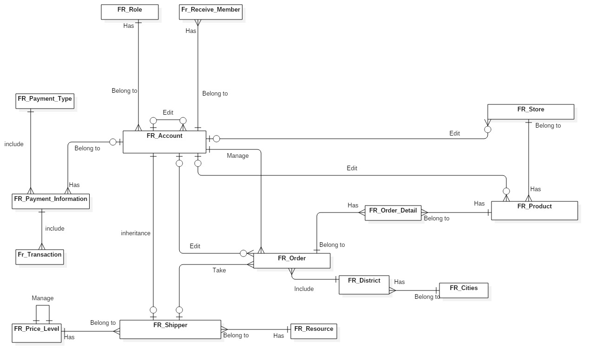**Conceptual Diagram**

**Data Dictionary**

|  |  |  |
| --- | --- | --- |
| **Entity Data Dictionary: Describe content of all tables** | | |
| **No.** | **Table Name** | **Description** |
| 1 | Fr_account | Contain account information |
| 2 | Fr_city | Contain city information |
| 3 | Fr_district | Contain district data of city |
| 4 | Fr_order | Contain data of order’s list |
| 5 | Fr_order_detail | Contain data of order |
| 6 | Fr_payment_information | Contain data of payment |
| 7 | Fr_payment_type | Type of payment |
| 8 | Fr_price_level | Select price level for shipper |
| 9 | Fr_product | Contain data of every product of store |
| 10 | Fr_role | Contain data role of member |
| 13 | Fr_shipper | Contain data of shipper |
| 14 | Fr_source | Contain source of data |
| 15 | Fr_store | Contain data of store |